Data Structure and Algorithm
Laboratory Activity No. 14

Tree Structure Analysis

Submitted by: | Instructor:
Nerio, Hannah Grace A. | Engr. Maria Rizette H. Sayo

November 06, 2025

Objectives
Introduction
An abstract non-linear data type with a hierarchy-based structure is a tree. It is made up of links connecting nodes (where the data is kept). The root node of a tree data structure is where all other nodes and subtrees are connected to the root.

This laboratory activity aims to implement the principles and techniques in:
- To introduce Tree as Non-linear data structure
- To implement pre-order, in-order, and post-order of a binary tree
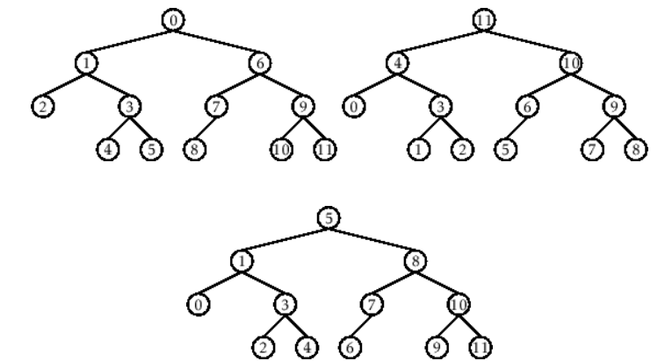

- Figure 1. Pre-order, In-order, and Post-order numberings of a binary tree

Methods
  - Copy and run the Python source codes.
  - If there is an algorithm error/s, debug the source codes.
  - Save these source codes to your GitHub.
  - Show the output

    - Tree Implementation

class TreeNode:
def __init__(self, value):
self.value = value
self.children = []

def add_child(self, child_node):
self.children.append(child_node)

def remove_child(self, child_node):
self.children = [child for child in self.children if child != child_node]

def traverse(self):
nodes = [self]
while nodes:
current_node = nodes.pop()
print(current_node.value)
nodes.extend(current_node.children)

def __str__(self, level=0):
ret = " " * level + str(self.value) + "\n"
for child in self.children:
ret += child.__str__(level + 1)
return ret

# Create a tree
root = TreeNode("Root")
child1 = TreeNode("Child 1")
child2 = TreeNode("Child 2")
grandchild1 = TreeNode("Grandchild 1")
grandchild2 = TreeNode("Grandchild 2")

root.add_child(child1)
root.add_child(child2)
child1.add_child(grandchild1)
child2.add_child(grandchild2)

print("Tree structure:")
print(root)

print("\nTraversal:")
root.traverse()

Questions:
- What is the main difference between a binary tree and a general tree?
- In a Binary Search Tree, where would you find the minimum value? Where would you find the maximum value?
- How does a complete binary tree differ from a full binary tree?
- What tree traversal method would you use to delete a tree properly? Modify the source codes.

Results
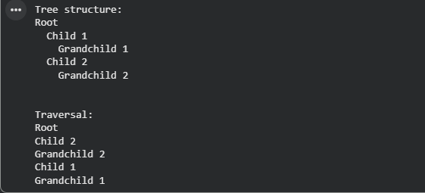

Figure 1 Screenshot of program
Questions:
- What is the main difference between a binary tree and a general tree?
The main difference between a binary tree and a general tree lies in the number of children that each node can have. A binary tree is a more structured form of tree where every node can have at most two children—commonly referred to as the left child and the right child. This two-child restriction creates a more predictable and constrained structure, which is especially useful for tasks such as searching and sorting, as seen in Binary Search Trees (BSTs) and heaps. On the other hand, a general tree is a more flexible type of tree structure where a node can have any number of children. This makes it ideal for representing complex, real-world hierarchies like organizational charts, file systems, or family trees, where the number of subordinates (children) can vary. The flexibility of a general tree allows it to model a wider range of data structures, but the binary tree's limited child nodes make it better suited for certain algorithmic tasks that require a more rigid and defined structure.
- In a Binary Search Tree, where would you find the minimum value? Where would you find the maximum value?
In a Binary Search Tree (BST), the minimum and maximum values are easily identifiable due to the tree's inherent structure, which follows a rule: for any given node, all the nodes in the left subtree have smaller values, and all the nodes in the right subtree have larger values. To find the minimum value, you would begin at the root and keep moving left, as each left child will contain a value smaller than its parent. Eventually, you will reach the leftmost node, which contains the smallest value in the tree. Conversely, to find the maximum value, you would start at the root and keep moving right, since each right child contains a larger value than its parent. The rightmost node will hold the largest value in the BST. This structure allows you to efficiently find the minimum and maximum values by simply traversing the leftmost or rightmost paths of the tree, without needing to check every node.

- How does a complete binary tree differ from a full binary tree?
A complete binary tree and a full binary tree are both types of binary trees, but they differ in how the nodes are structured and filled. A complete binary tree is a tree where all the levels, except possibly the last, are completely filled. The last level is filled from left to right, meaning that there are no gaps between nodes at any level, and all nodes are as close to the root as possible. This structure ensures that the tree is balanced and compact, and is commonly used in heaps, where maintaining such a structure is crucial for efficient operations like insertion and deletion. In contrast, a full binary tree is a tree where every node has either zero or exactly two children. This means that no node can have just one child; every non-leaf node must have two children. While full binary trees can also be balanced, their structure is more rigid compared to complete binary trees. The key difference is that in a full binary tree, the number of children is more strictly controlled, whereas in a complete binary tree, the tree fills level by level without any gaps, ensuring the most compact representation.

- What tree traversal method would you use to delete a tree properly? Modify the source codes.

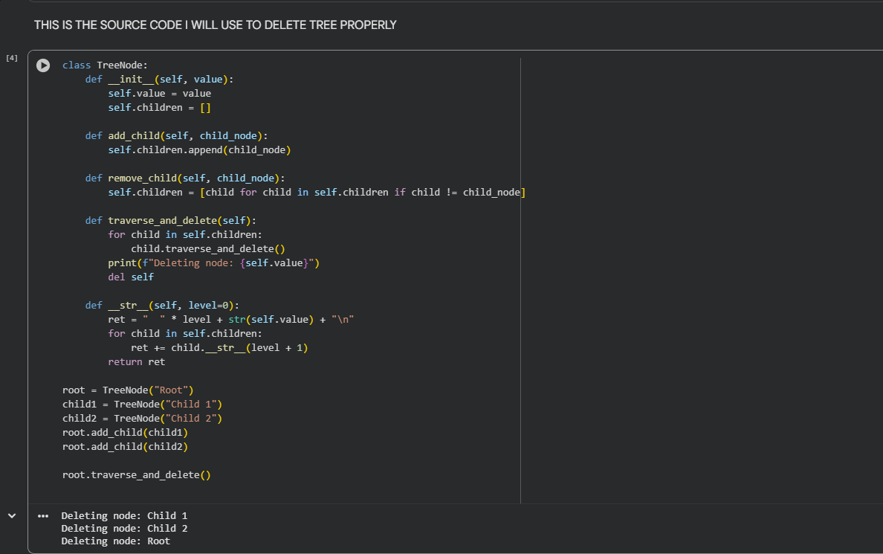

Conclusion
In conclusion, the differences between the various tree structures and traversal methods are crucial for understanding how trees are used in organizing and manipulating data. A binary tree is a more structured tree where each node can have at most two children, making it ideal for efficient search and sorting tasks. In contrast, a general tree allows each node to have an arbitrary number of children, making it more flexible for representing complex hierarchies, like organizational charts or file systems. In a Binary Search Tree (BST), the minimum value is located at the leftmost node, while the maximum value is found at the rightmost node. This property, which ensures that values are organized in ascending order, makes finding the extremes of the tree quick and efficient. The distinction between a complete binary tree and a full binary tree lies in their structure. A complete binary tree fills each level from left to right, ensuring a compact and balanced structure. A full binary tree, however, requires that every node has either zero or exactly two children, meaning no node can have just one child. Finally, when deleting a tree, the post-order traversal method is preferred. This method deletes the children before the parent node, ensuring that no references to children are left behind and preventing issues such as memory leaks. By using post-order traversal, the tree can be deleted efficiently and safely, ensuring proper memory management. These fundamental tree structures and traversal techniques are essential for understanding how trees operate and are manipulated, which is critical for various algorithms and applications that require efficient data organization.

References
[1] Co Arthur O.. “University of Caloocan City Computer Engineering Department Honor Code,” UCC-CpE Departmental Policies, 2020.
[2] “Google Colab.” https://colab.research.google.com/drive/15VQFpYiDmEFReESjnEgw_GOEUdAe4rty#scrollTo=cWMXaWBbrlSv

